**Tier-1 Presentation layer (**network, Route 53, CloudFront, frontend**).**

**Created hosted zone with custom domain name.**

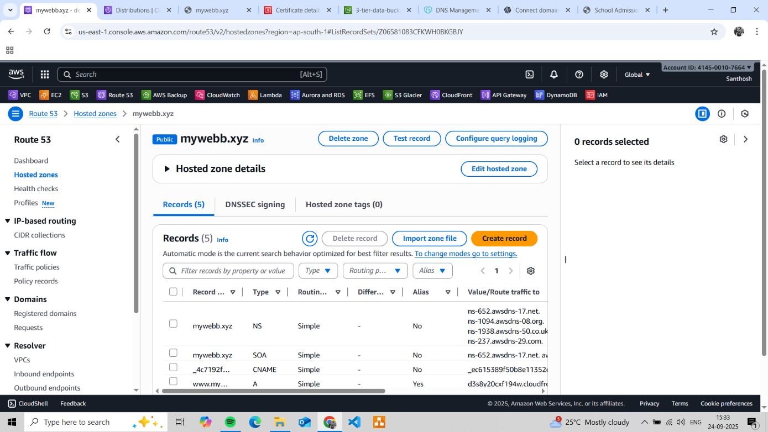

**Created CloudFront distribution to serve frontend data whenever the custom domain name is searched.**

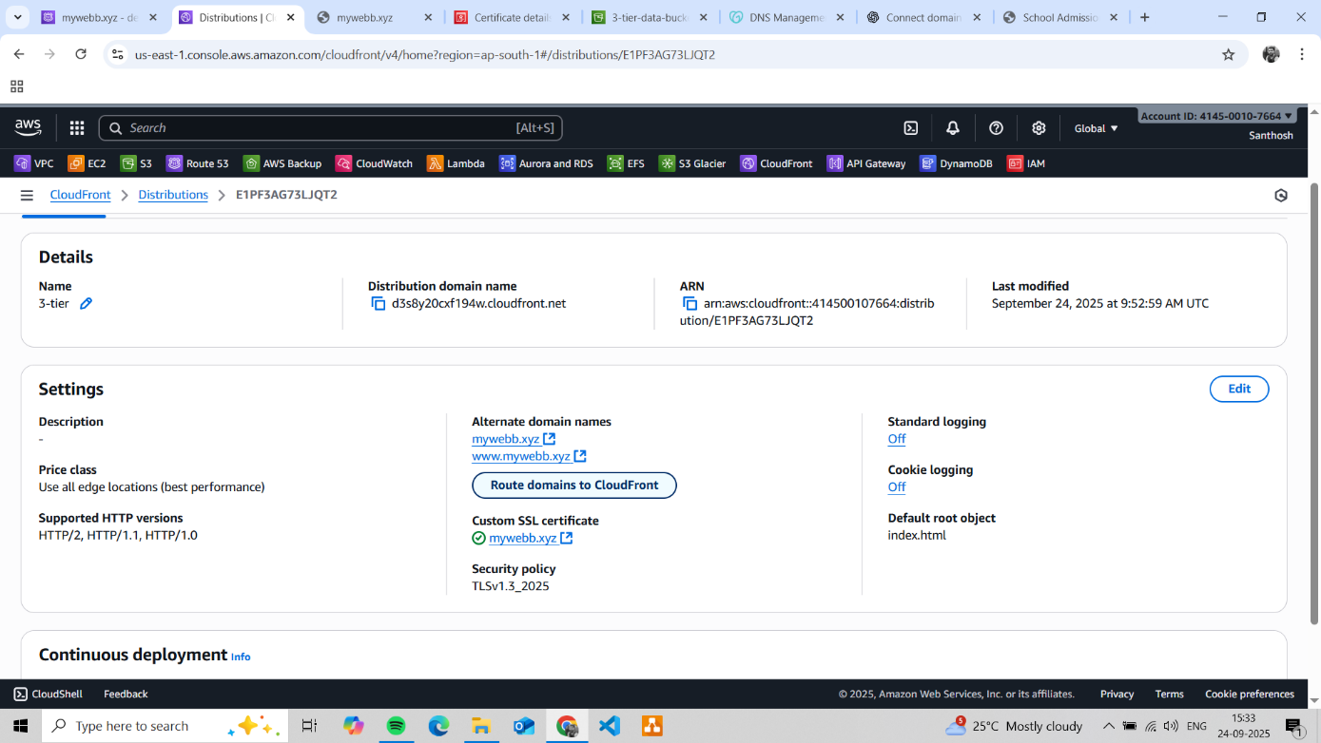

**Getting SSL certificate for custom domain for https access from amazon certificate manager.**

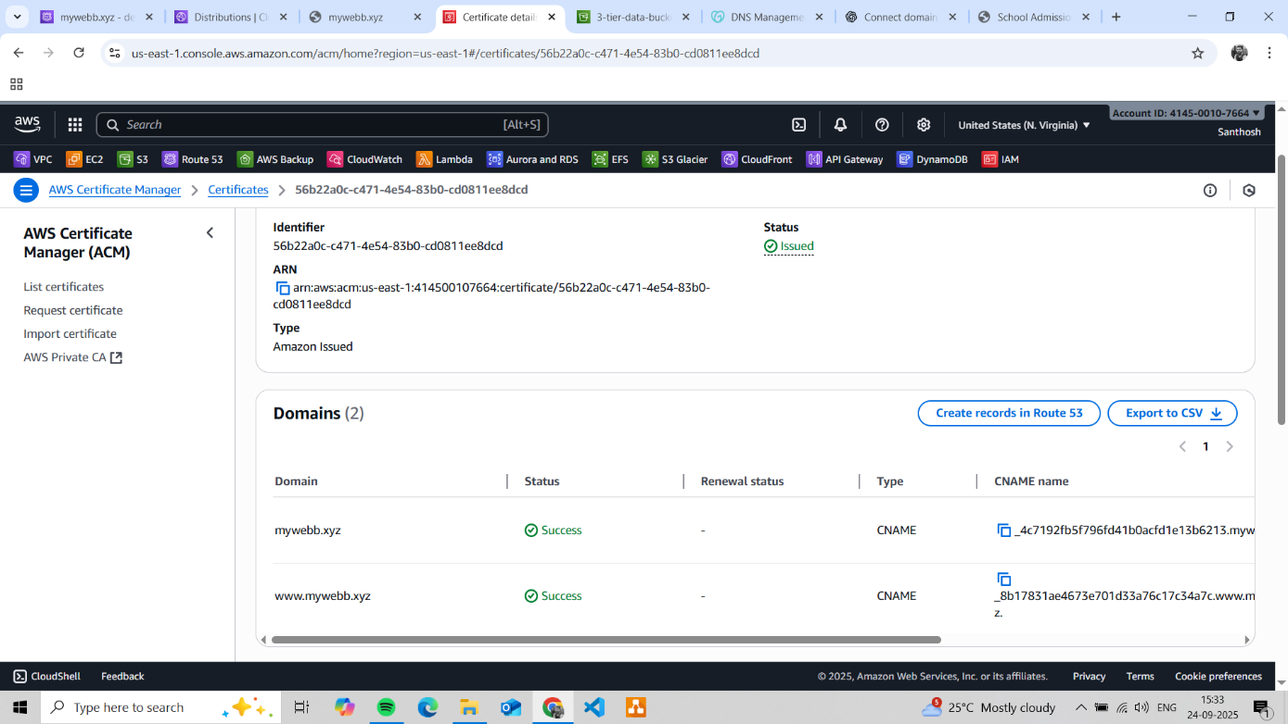

**Created S3 bucket where frontend data is stored in a bucket.**

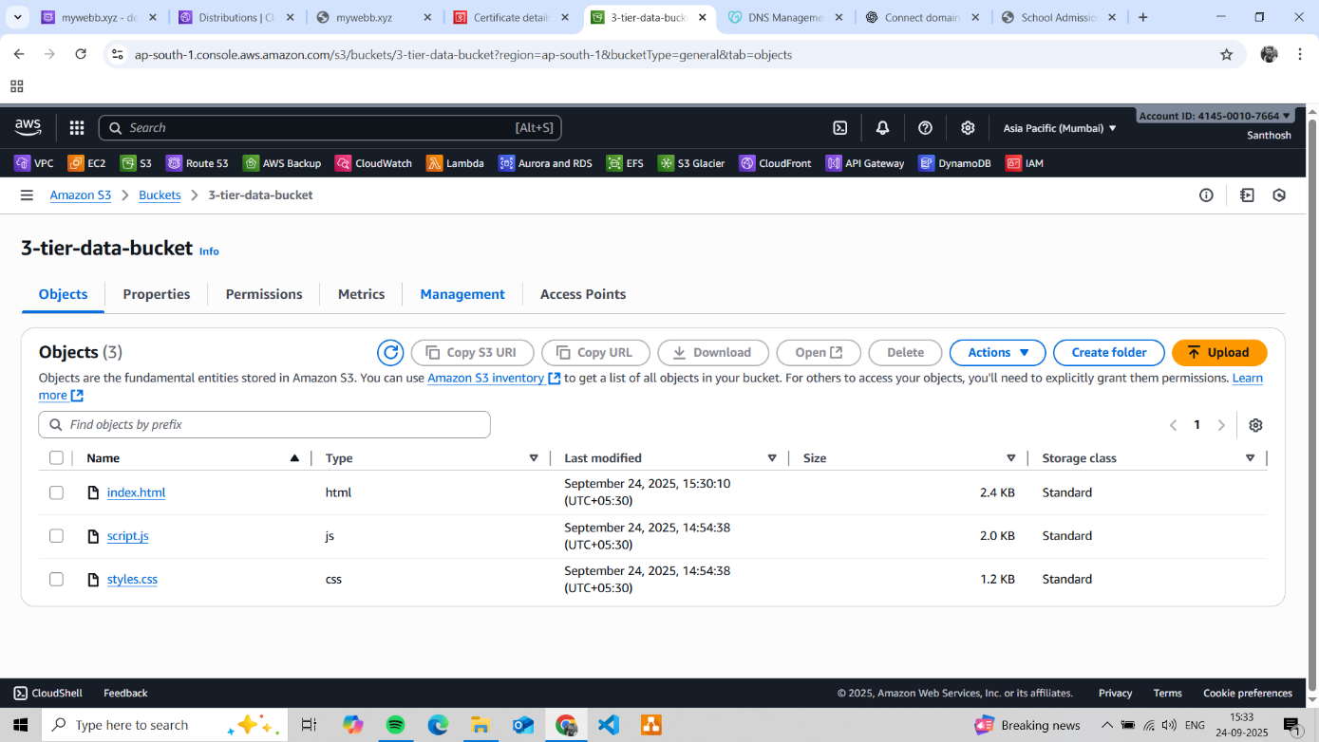

**CloudFront serving the frontend whenever the domain name is Accessed.**

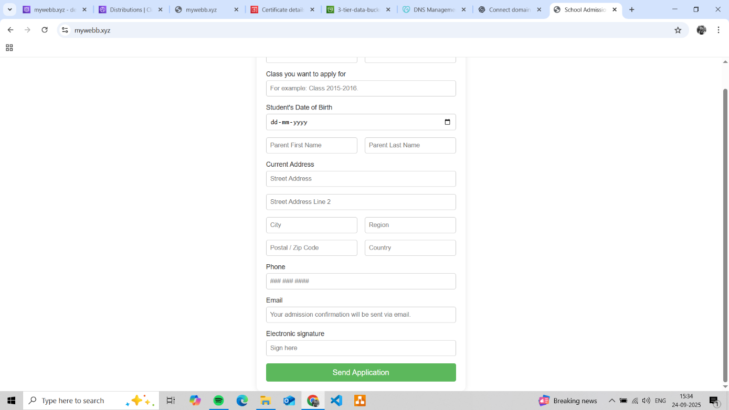

**Creating virtual private network in cloud with 2 public subnets and 2 private subnets.**

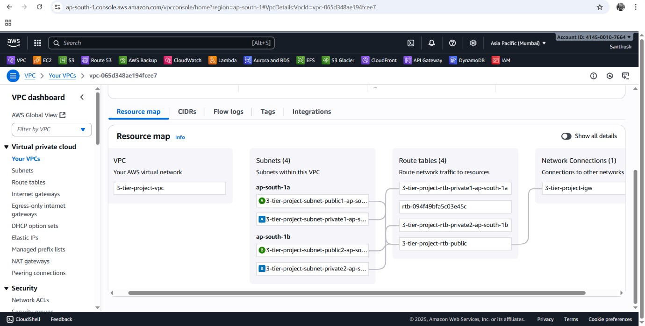

**Tier 2 Application layer Backend or business logic.**

**IAM role for EC2 to access the objects in s3 bucket.**

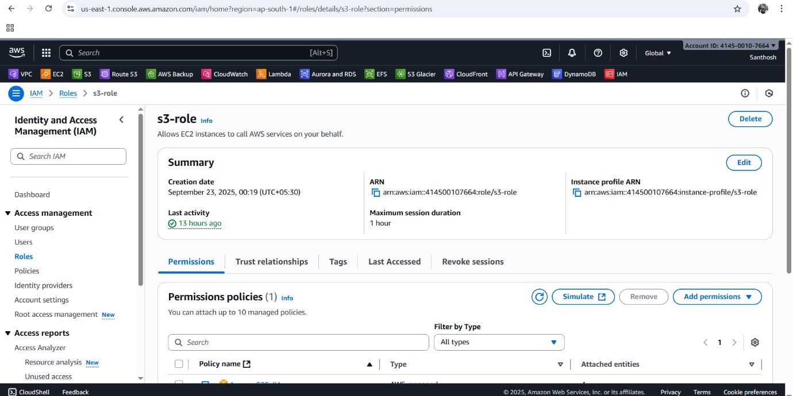

**Launch template (prior provisioning for scalability)**

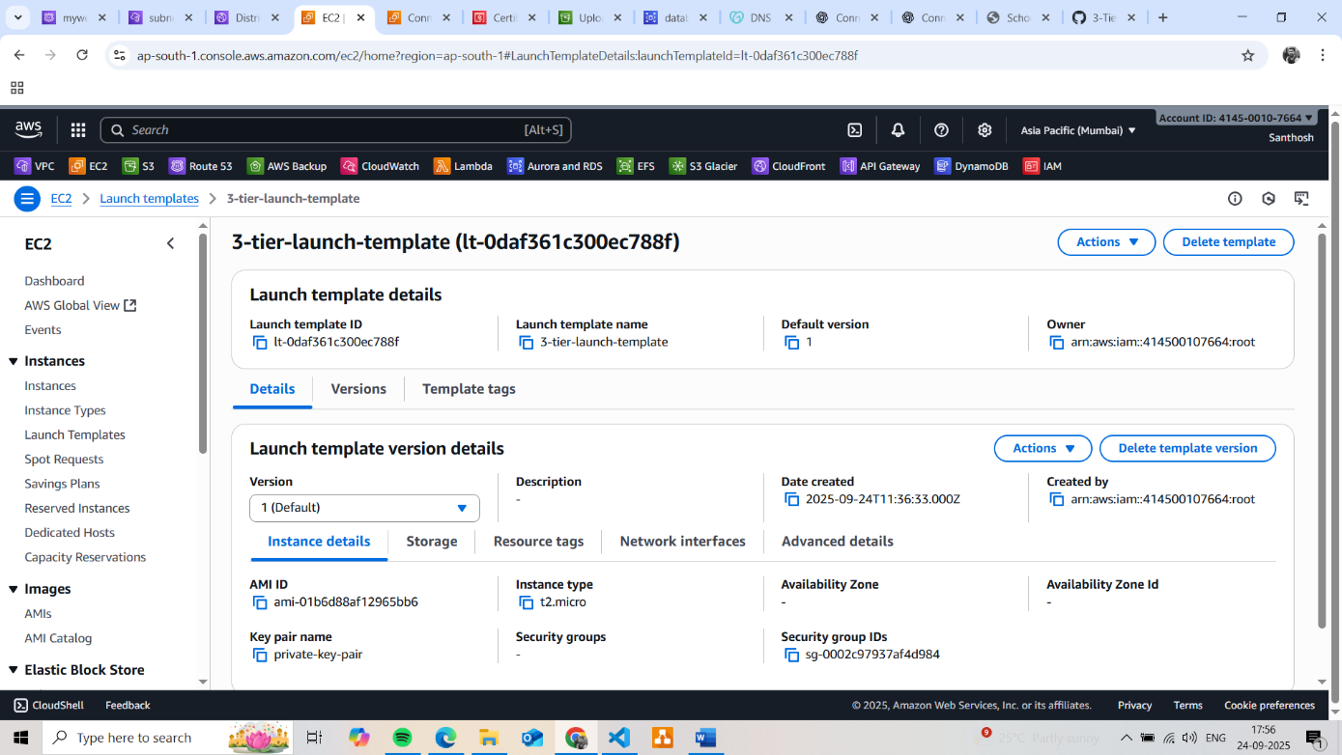

**Load balancer for to handle unexpected/ Sudden spike in traffic.**

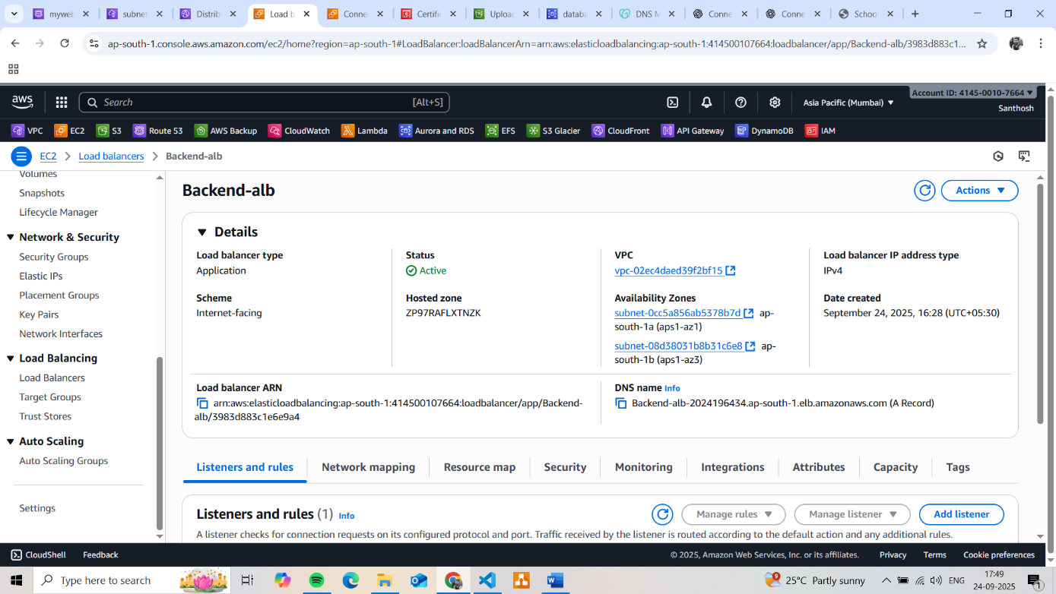

**created target group to provide load balancer destination where the traffic should be sent.**

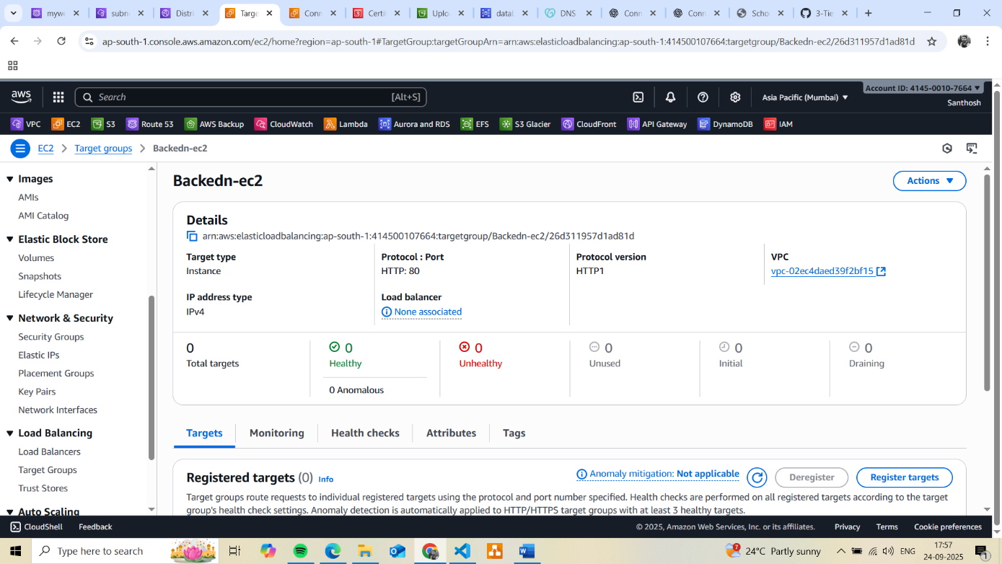

**Autoscaling group for automatically scale in or scale out depending traffics request.**

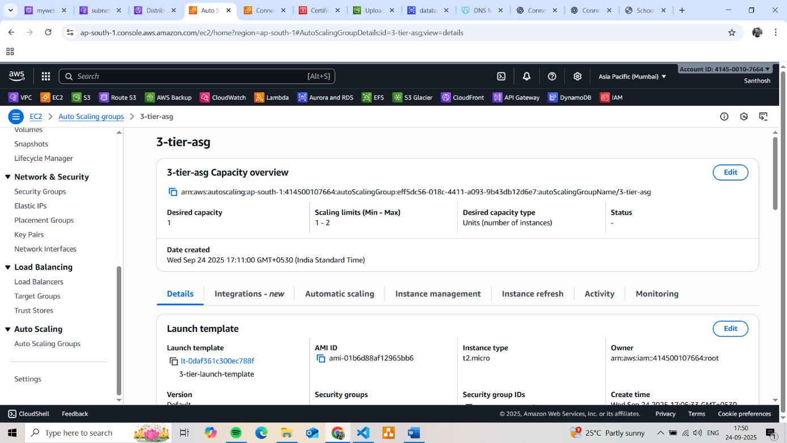

S3 bucket store the Backend logic in backend.js file

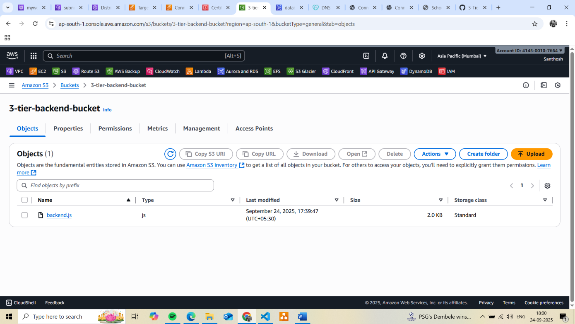

**Tier 3 Database layer (deploying database in private subnets not accessible public.)**

Create database in private Subnet.

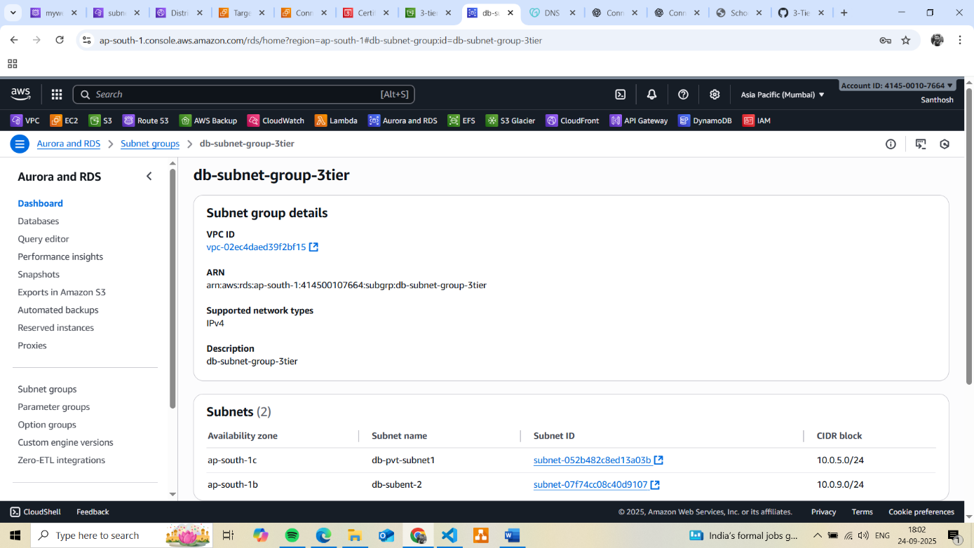

Creating MYSQL data base server.

